.


LA GRANDEE INTERNATIONAL COLLEGE
Simalchaur, Pokhara Nepal
A Project Proposal
On
“Student Fine management system”

Submitted to:
Bachelor of Computer Application(BCA) Program
In partial fulfilment of the requirements for the degree of BCA under
Pokhara University
Submitted by:
Name: | Course | Semester | P.U. Registration Number
Shital Thapa | BCA | 2nd | 2025-1-53-0348
Aastha GC | BCA | 2nd | 2025-1-53-0312

Date:11/06/2026

Acknowledgement
The satisfaction that accompanies after the successful completion of any task will be incomplete without mentioning the people whose ceaseless and relentless cooperation, constant guidance and encouragement made this project possible.
We are grateful to our project supervisor Mr Arpan Pokhrel, our faculty teacher Mr. Ramesh Chalise, for the guidance, inspiration and constructive suggestions that helped us in the preparation of this project.
We are also appreciative among each other and have understood that teamwork, the designation of the task per the skillset one portrays, constant synchronisation and monitoring of progress and instilling new knowledge and skill is imperative for the success of any given work.
Sincerely,
Shital Thapa
Astha GC

TABLE OF CONTENT

1.Introduction 6
2.Problem Statement 8
3.Objectives 9
4.Background Study 10
5.Requirement Document 11
6. Use case 12
7. Detailed Timeline 13
8.Gantt Chart 14
9.Reference 15
Conclusion 16

LIST OF FIGURES
Figure 1Use case of Fine Management 15
Figure 2Waterfall model 16
Figure 3Gantt Chart 17

1.Introduction
Student Fine Management system is a software project used to manage student fines in school/colleges and other many educational institutions. It helps to keep records of fines , Payments and student details in an easy and organised way. The system reduces manual work, save times, and improve accuracy in maintain fine records. It is useful for tracking paid and unpaid fines efficiently. In many institutions fines are imposed on students for various reasons such as late payment of fees, library book delays, breaking institutional rules, or failure to submit assignments on time. These fines records are maintained manually in registers or paper files which is a time consuming process. The student fine management system provides a digital platform where administrators can easily manage all fine related activities. The system allows the admin to store student information, add new fine record, update payment status, search student details, and generate reports whenever required. By using this system, educational institutions can reduce paper work and improve the accuracy and efficiency of fine management.
The system is designed in a simple and user friendly manner so that it can be easily used by administrative staff without requiring advance technical knowledge. Each student is assigned a unique identification number through which there fine details can be accessed quickly. The system also helps maintain transparency because students fines record can be stored systematically whenever necessary. The student fine management system generally consist of different modules such as student management, fine management, payment management. The student Management module stores basic student details such as name, roll no, class and contact information. The fine management module records the type of fine, amount, date and reason of the file. The payment management module keeps track of whether the fine has been paid or not. The report module helps generate summarizes of collected fines and pending dues.
Traditionally, fine management systems in many institutions are handled manually by administrative staff. This manual process requires a lot of paper work and continuous effort to update records regularly. As the number of students increases, maintaining fine records becomes more complex. There may be problems such as loss of records, duplicate entries incorrect calculations, difficultly in searching student details and delays in updating a payments status. In addition, generating reports about collected fines and pending dues becomes challenging in a manual system. Therefore, there is a need for an automated and computerized system that can manage student fine records accurately and efficiently.
The student fine management system is develop with the objective of simplifying the fine management process and improving administrative efficacy. The system stores all information in a data base, which allows easy retrieval and modification of records. Each student is assigned a unique identification number or roll no, making it easier to access there fie details quickly. Administrators can also keep track of paid and unpaid fines, which helps maintain transparency and accountability with in a institution.
For our project, we divided work between us from the beginning. Documentations and coding was divided between all of us. Mainly, Gantt chart was sketched and requirement traceability matrix was done by Aastha G.C. similarly, Flowchart and DFD was graphically designed by Shital Thapa. Research about project related information and testing platform and was handled by Arpan Pokhrel. However, each member contributed to the coding and testing of each module and provided there variable inputs to improve the system.
While doing research we knew that thee were many difficulties regarding collection of data, multiple set booking, data was in accurate, adaptation in system according to government policy was difficult while changing. By keeping this difficulties we made this system and we were successful to minimize this difficulties using C++.
Going digitally is one of the great idea in this time period because each and every thing has been digitalized and many of the work pressures will be overcome, work will be much faster and we will be able to find each and every thing in much more efficient way. We will be able to deliver better experience for our customers. Analysing of data will be much more easier, so going digitally is best method.

2.Problem Statement
There were many difficulties as this was our first programming based project. Although there were many problems we were able to solve an implement it on our project. Lots of errors and many failures occur while attempting the entire task given in this project. Data collection, multiple seat booking, data was inaccurate, adaptation in system according to government policy and organizational change were difficult in the existing system. So to overcome these difficulties our program was intended.
At beginning people use to store/write data in manual form which results misplaced or loss of data. Previous system used to take a lot of spaces, prone to damage and being misplaced, hard to make changes, take a lot of access time, lack of security, higher cost, large on-going staff training cost, system id dependent on good individual, misinterpretation among peoples.
List of the following issues as secondary but prominent issues- can make problem statements in both micro and macro-level.
- Manual fine management is time-consuming.
- Paper records may cause errors and data loss.
- Difficult to track paid and unpaid fines.
- Students may not receive timely fine updates.
- No centralized system for fine management.
- Manual fine calculation can create mistakes.
- Report generation is slow and inefficient.

3.Objectives
A student fine management system is designed to automate and simplify the process of managing fines imposed on students in educational institutions. It helps administrators keep proper records, track payments, and ensure transparency in the fine collection process.
- To automate the process of managing student fines.
- To maintain accurate and organized fine records.
- To reduce manual work and save time for administrators.
- To track paid and unpaid fines easily.
- To minimize errors in calculation and record keeping.
- To provide quick access to student fine details.
- To generate reports efficiently when required.
- To improve transparency and accountability in the system.

4.Background Study
The background section should discuss your findings in a chronological (Sequential Manner) manner to accentuate the progress in the field and the missing points that need to be addressed.
The project background should include information about the reasoning why you want to implement this specific project in this specific location in this specific manner. It must explain the current situation and its problems and the way in which you want to solve these problems.
The student Fine management system is developed to replace traditional manual methods used in educational institutions for managing student fines. In many schools and colleges, fines related to late submissions, rule violations, or library delays are sill recorded using paper registers or basic spread sheets. This often leads to errors, data loss, and difficulty in tracking records efficiently.
Earlier studies on student management systems show that manual processes are the time consuming and inefficient, especially as the number of students increases.
Educational institutions face challenges in maintaining accurate records and generating reports without an automated system.
Research also shows that computer based student management systems help in organizing student data, improving accessibility and reducing administrative workload.
Similarly, studies on fines and fee management systems highlight that manual fine collection often causes confusion, lack of transparency, and difficulty in tracking payments. To solve these issues, automated systems are developed to ensure proper record keeping and easy monitoring of dues.
In conclusion, the background study shows that there is a strong need for a computerized student fine management system to improve accuracy, save time, reduce workload, and increase transparency in educational institutions.

5.Requirement Document
5.1 Functional Requirements
- Add student fine records.
- Update an delete fine details.
- Store student information and fine reason
- Track paid and unpaid fines.
- Search student fine records.
- Update payment status
- Generate fine reports(daily/monthly/Yearly)
- View student fine history.

2.Non Functional requirements
- User friendly system
- Fast performance
- Secure data storage
- Authorized access only
- Reliable operation
- Easy maintenance
- Accurate record handling
- Backup and recovery support
- Simple interference
- Efficient processing

6. Use case

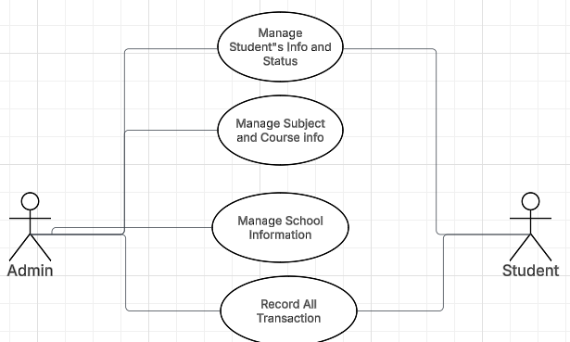
Figure 1Use case of Fine Management

7. Detailed Timeline
The waterfall model is a traditional, linear, and sequential software development lifecycle(SDLC) approach where each phase, requirements, design, implementation, testing, deployment, and maintenance must be completed before moving to next step. This model is suitable for project with stable and well defined requirements.
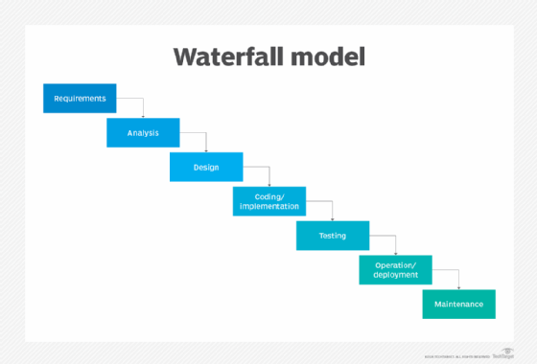
Figure 2Waterfall model

Why does this model suitable for this project?
- Easy documentation
- Simple and structured development
- Clear requirement
- Suitable for academic project
- Easy testing and maintenance
- Less complex system
- Better project management

8.Gantt Chart

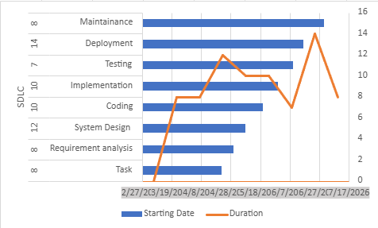
Figure 3Gantt Chart

9.Reference
- Aryan Dikshit, Ayush Shrivastava, Rajesh Kumar – Student Fine Management System
https://www.researchgate.net/publication/362379146_Student_Management_System?utm_source=chatgpt.com
- ResearchGate — Research papers and journals for student management systems
https://www.researchgate.net/publication/359615804_student_fine_management_system?utm_source=chatgpt.com
- Radhika Bhanushali — Student Management System
https://www.researchgate.net/publication/362379146_Student_Management_System?utm_source=chatgpt.com

Conclusion
The student fine management system is a useful and efficient system developed to manage student fines in an organized way. It helps schools and colleges maintain accurate records of fines, payments, and student details. The system reduces manual work, saves time, and minimizes errors in calculation and record keeping.
By using this system, administrators can easily add, update, search, and manage fine records. Students can also get clear information about their pending fines and payment status. The project improves transparency, security, and overall management efficiency.
The student fine management system is a simple and effective solution that makes the process of handling student fines faster, easier, and more reliable for educational institutions. The system can also generate reports easily, making administrative work more effective and organized. The project reduces manual work and saves time for administrators by allowing the to add, update, search, and manage student fine records quickly and accurately.
From an educational perspective, this project is highly useful for beginner students in computer science and information technology. It provides practical knowledge about programming, database management, CRUD operations and software development students can learn how real world management systems work and how technology can solve practical problems school and colleges.
In conclusion, the student fine management system is a useful, reliable and practical project that helps educational institutions manage student fine effectively. It improve efficiency, accuracy, transparency, and discipline management while reducing paper work and manual effort. This project demonstrated how digital technology can make administrative tasks easier, faster, and more secure for both students and administrators.

